Customer Shopping Behaviour Analysis

Problem Statement
A leading retail company wants to better understand its customer’s shopping behaviour in order to improve sales, customer satisfaction, and long-term loyalty. The management team has noticed changes in purchasing patterns across demographics, product categories and sales channels (online vs offline). They are particularly interested in uncovering which factors, such as discounts, revies, seasons, or payment preferences, drive consumer decisions and repeat purchases.
The client has asked “How can the company leverage consumer shopping data to identify trends, improve customer engagement, and optimise marketing and product strategies?”

- Project overview
This project analyses customer shopping behaviour using transactional data from 3900 purchases across various product categories. The goal is to uncover insights into spending patterns, customer segments, product preferences, and subscription behaviour to guide strategic business decisions.
This will show a full pipeline of analysis starting from Excel → Python → SQL → Power Bi

- Dataset Summary
Rows | 3900
Columns | 18
Customer demographics | Age, Gender, Location, Subscription Status
Purchasing details | Item purchased, Category, Purchase Amount, Season, Size, Colour
Shopping behaviour | Discount Applied, Promo Code Used, Previous Purchases, Frequency of Purchases, Review Rating, Shipping Type
Missing data | 37 values in Review Rating column

- Exploratory Data Analysis using Python

Begin with data preparation and cleaning in Python
- Load data: imported the dataset with pandas
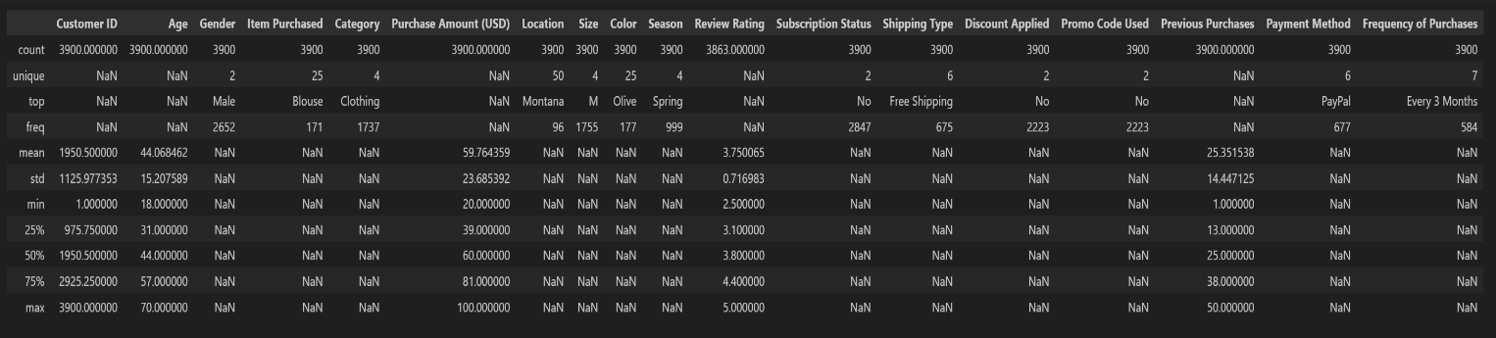
- Initial exploration: Used df.info () to check the structure and .describe() for summary statistics
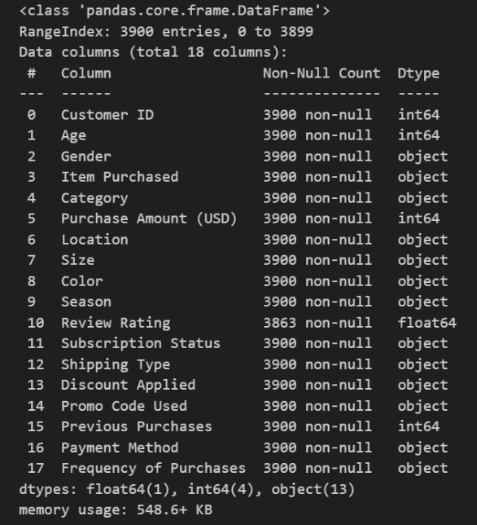

- Handling Missing Data: checked for null values and imputed missing values in the Review Rating column using the median rating of each product category.
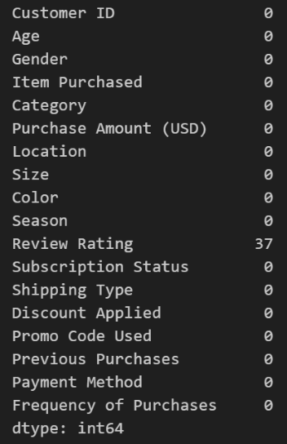
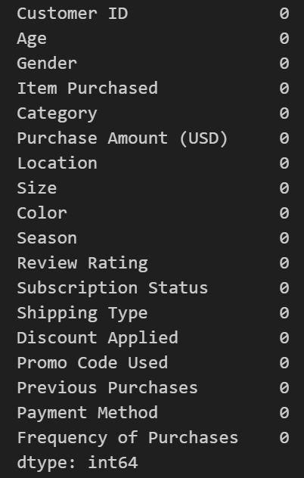

- Column standardisation: the columns were renamed to snake case for better readability and documentation.
- Feature engineering:
- Created age_group column by binning customer ages
- Created purchase_frequency_days column from purchase data
- Data Consistency Check: Verified if discount_applied and promo_code_used were redundant; dropped promo_code_used.
- Database Integration: Connected Python script to PostgreSQL and loaded the cleaned Data Frame into the database for SQL analysis.

- Data Analysis using SQL

Structured analysis in Microsoft SQL server was performed to answer key business questions:

- Revenue by Gender: compared total revenue generated by male vs female customers

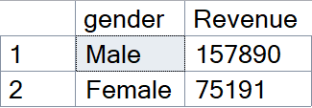

- High-spending discount users: identified customers who used discounts but still spent above the average purchase amount (top 25 shown)
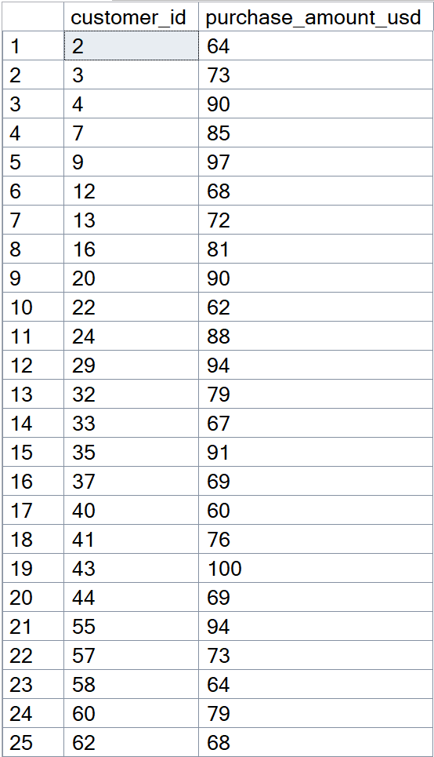

- Top 5 products by rating: found products with the highest revenue ratings.

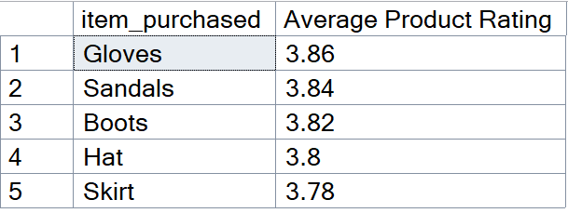

- Shipping type comparison: compared average purchase amounts between standard and express shipping.
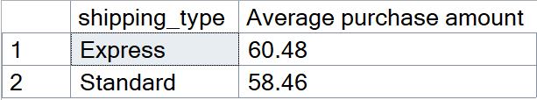

- Subscribers vs non-subscribers: compared average spend and total revenue across subscription status

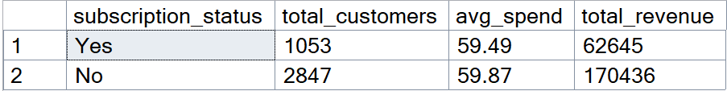

- Discount-dependent purchases: identified 5 products with the highest percentage of discounted purchases.
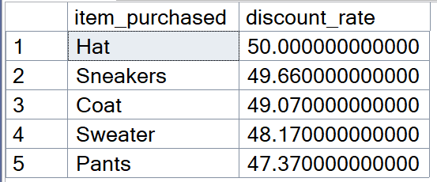

- Customer segmentation: classified customers into New, Returning and Loyal segments based on purchase history.

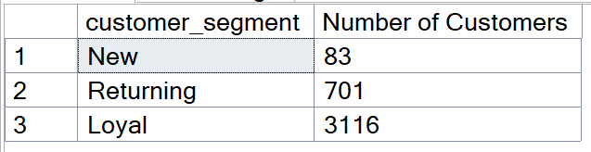

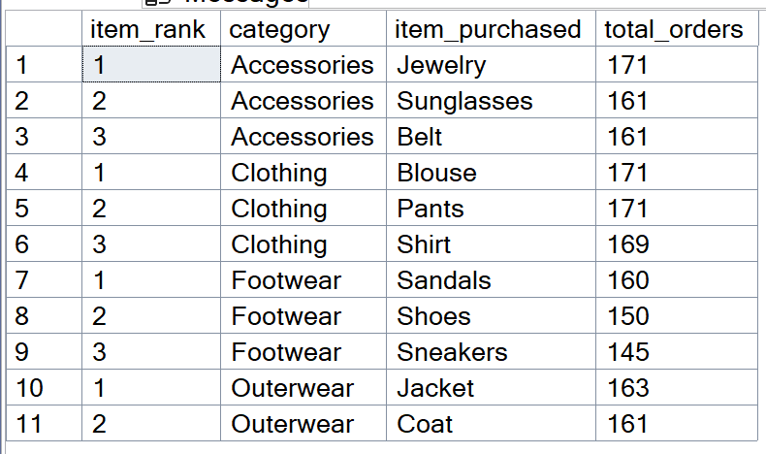
- Top 3 products per category: listed the most purchased products within each category.

- Repeat buyers and subscriptions: checked whether customers with >5 purchases are more likely to subscribe.

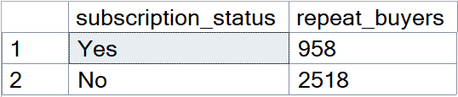

- Revenue by age group: calculated total revenue contribution of each age group.

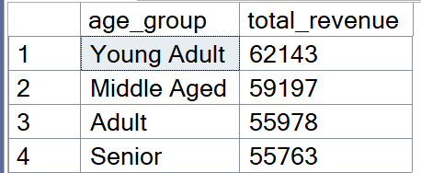
- Power BI Dashboard

An interactive dashboard was built in Power BI to present some insights visually.

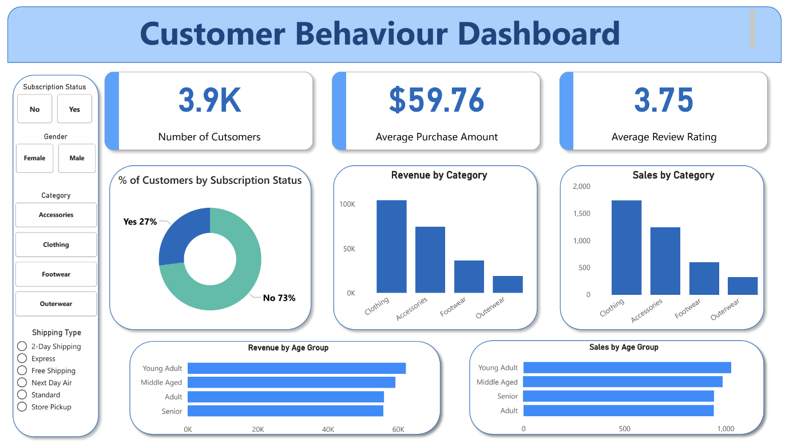

- Business Recommendations

Boost Subscriptions – Promote exclusive benefits for subscribers

Customer loyalty programmes – reward repeat buyers to move them into the ‘Loyal’ category

Review discount policy – balance sales boosts with margin control

Product positioning – highlight top-rated and best-selling products with campaigns

Target marketing – focus efforts on high- revenue age groups and express shipping users

